**Use Cases Diagram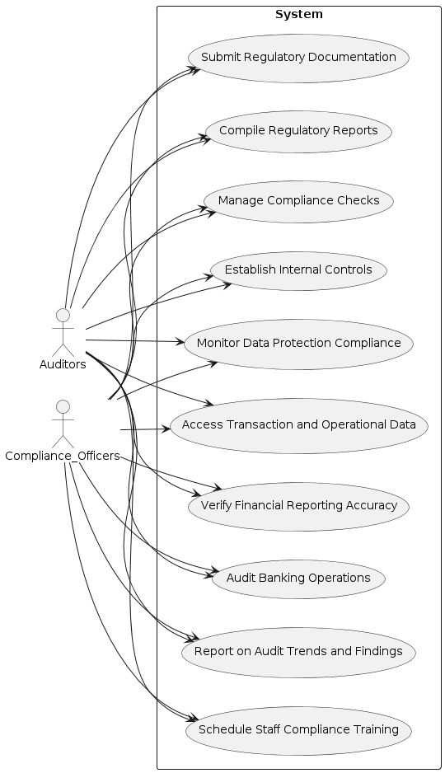 Activity Diagram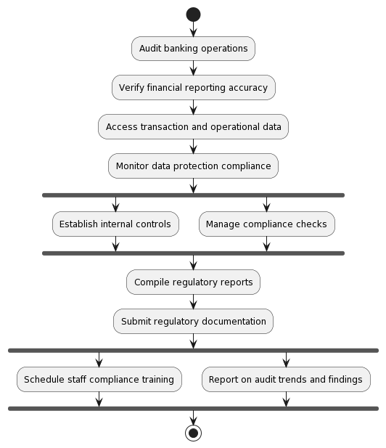 ERD Level 0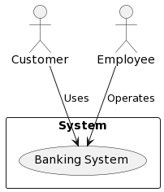 State Diagram**  
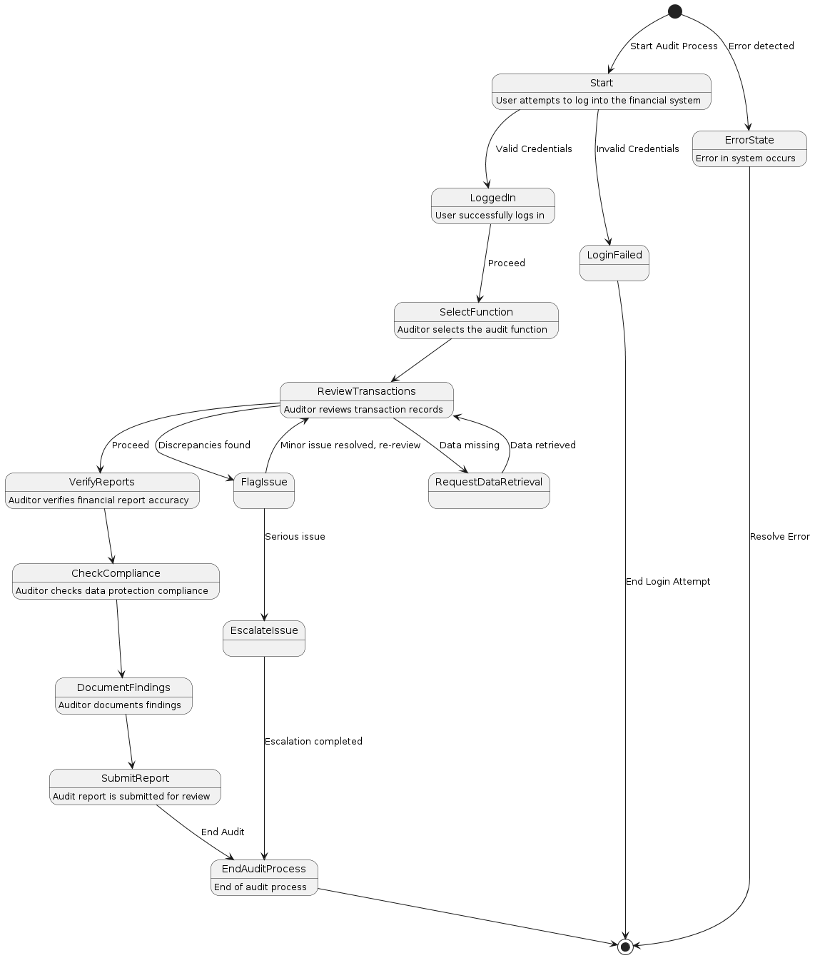

**Sequence Diagram**  
  
  
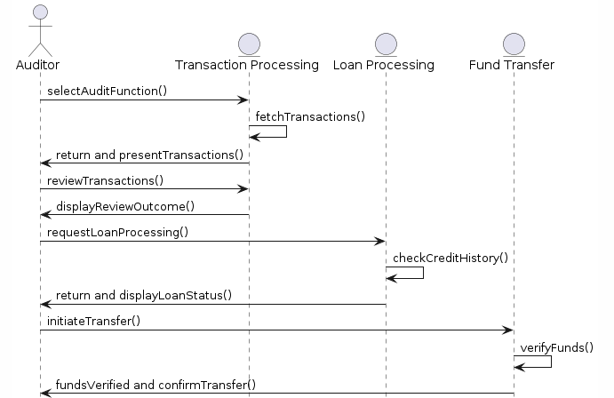  
  
  
  
  
  
  
  
  
  
  
  
  
  
  
  
  
  
  
  
  
  
  
  
**Collaboration Diagram**

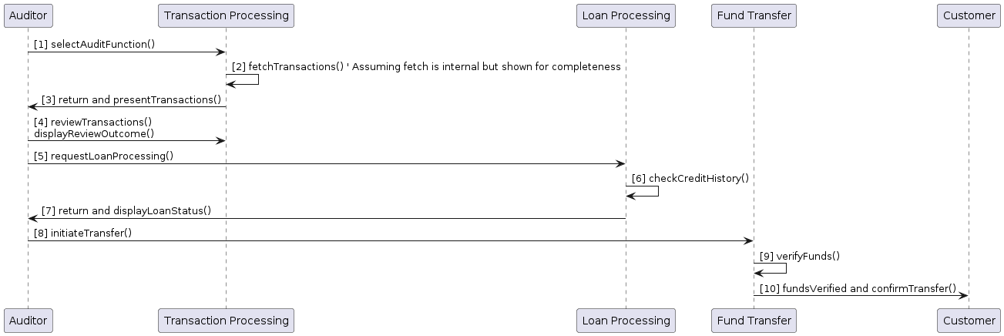

**Class Diagram**  
  
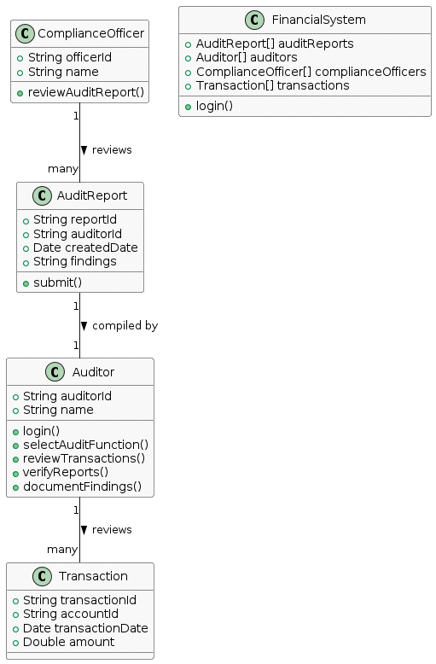

|  |  |
| --- | --- |
| UC04 | Auditors and Compliance Officers |
| Summary | Manage and track the audit process within the financial auditing system. |
| Actor | Auditor, Compliance Officer |
| Dependency | None |
| Preconditions | The auditor has been granted access to the financial auditing system.  All necessary financial data is up-to-date and accessible within the system. |
| Main Sequence | The auditor logs into the financial system.  The auditor selects the audit function.  The auditor reviews transaction records.  The auditor verifies the accuracy of financial reports.  The auditor checks compliance with data protection laws.  The auditor documents findings.  The audit report is submitted for review. |
| Alternative Sequences | If an error occurs at any state, the system transitions to the ErrorState.  If discrepancies are identified, the issue is flagged.  If data retrieval is necessary, the auditor requests manual data retrieval.  If the auditor escalates the issue, the process moves to the Escalation state. |
| Postconditions | The auditor has successfully logged out of the system.  A comprehensive audit report is prepared and submitted.  Any discrepancies found have been flagged for follow-up action.  All states lead to a defined end, ensuring the system's readiness for subsequent audit sessions. |